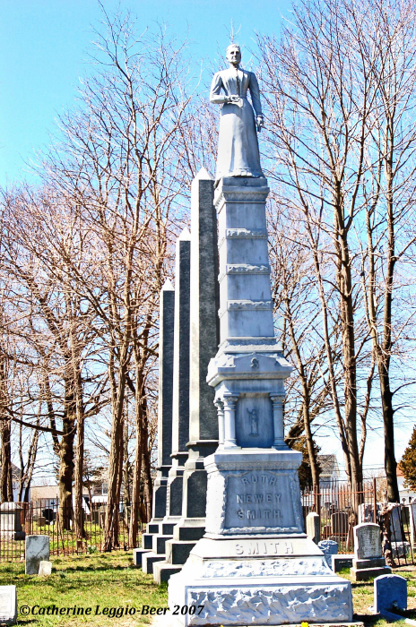 | Friends of the CRC  Membership Application  2016 Membership Drive  The Cemetery Restoration Committee (CRC), founded in 2006, is a group of independent volunteers brought together to restore five historic and sacred cemeteries located within the Village of Patchogue. This restoration project is undertaken in conjunction with the Greater Patchogue Foundation, Inc.  The Foundation Board recently created a Cemetery Task Force to build upon the work of the CRC and assist with fund raising to insure regular maintenance of the cemetery grounds and to complete its restoration. This task force includes the founder of the CRC, members of the Foundation, The Village Board of Trustees, and members of the community.

Membership is open to all descendants of those buried in the Lake View, Rice, Union, Gerard, and Old Episcopal Cemeteries and others wishing to help restore and maintain these historic and sacred grounds.

Membership Fees

Annual Membership:  $50 beginning January 1 each year | Lifetime Membership:  $500 one-time payment

I, ______________________________ (print name) wish to become a member of the Friends of the CRC.

_____ Attached is my $50.00 check for an annual membership.
_____ Attached is my $500.00 check for a lifetime membership.

Or
_____ Attached is my $ donation to help restore the above-mentioned cemeteries.

Please make your check payable to: The Greater Patchogue Foundation, Inc.
*************** Your donation is tax deductible! ****************

Signature_________________________________ Date_______________ email_________________
If you have family buried in any of the five cemeteries, please list their name(s) and indicate which cemetery (For additional room, please write on the back of this application):
__________________________________________________________________________________________________

__________________________________________________________________________________________________

My Address is: (Please print) | Mail to:  Cemetery Restoration Committee  c/o The Greater Patchogue Foundation, Inc.  15 North Ocean Avenue  Patchogue, NY 11772

Visit us at www.cemeteryrestorationcommittee.com
Restoring the Past…….For the Future!

